**Artificial Intelligence**

**Name:** Omar Saber

**B.N:** 550

**Date:** 5/6/2020

**Github Link:** <https://github.com/omarsaber2001/ECE001>

**Github** **Pages(Publish Pages):** <https://omarsaber2001.github.io/ECE001/index.html>

* **Application Brief**

**Since the seminal paper of Alan Turing in 1950 about the possibility of programming an electronic computer to behave intelligently, Artificial Intelligence (AI) has been experiencing for the past few decades a rapid growth in research and development. Such areas as expert systems, natural language processing, speech recognition, computer vision, robotics, etc. have significantly progressed, even though important problems still remain to be solved.**

**The present success of AI results, among other approaches, from the design of new system architectures that are able to use all the knowledge, including human expertise, available in a given domain. Such knowledge-based systems thus take human expertise into account in order to improve their own performances.**

**This paper aims at presenting an overview of the techniques and of the present possibilities and limitations, and future directions of AI. After a brief presentation of the basic concepts of AI, we will address the main issues involved in the development of AI systems. We will finally present the major trends for the future of AI.**

**Artificial intelligence is a technology that is already impacting how users interact with, and are affected by the Internet. In the near future, its impact is likely to only continue to grow. AI has the potential to vastly change the way that humans interact, not only with the digital world, but also with each other, through their work and through other socioeconomic institutions.**



* **ScreenShoot**

**Main Page:**

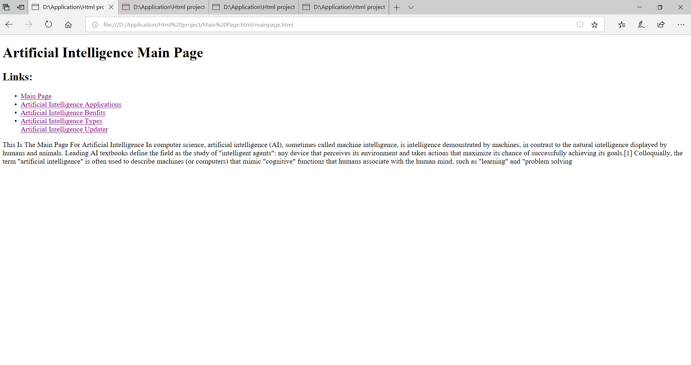

**Artificial Intelligence Applications:**

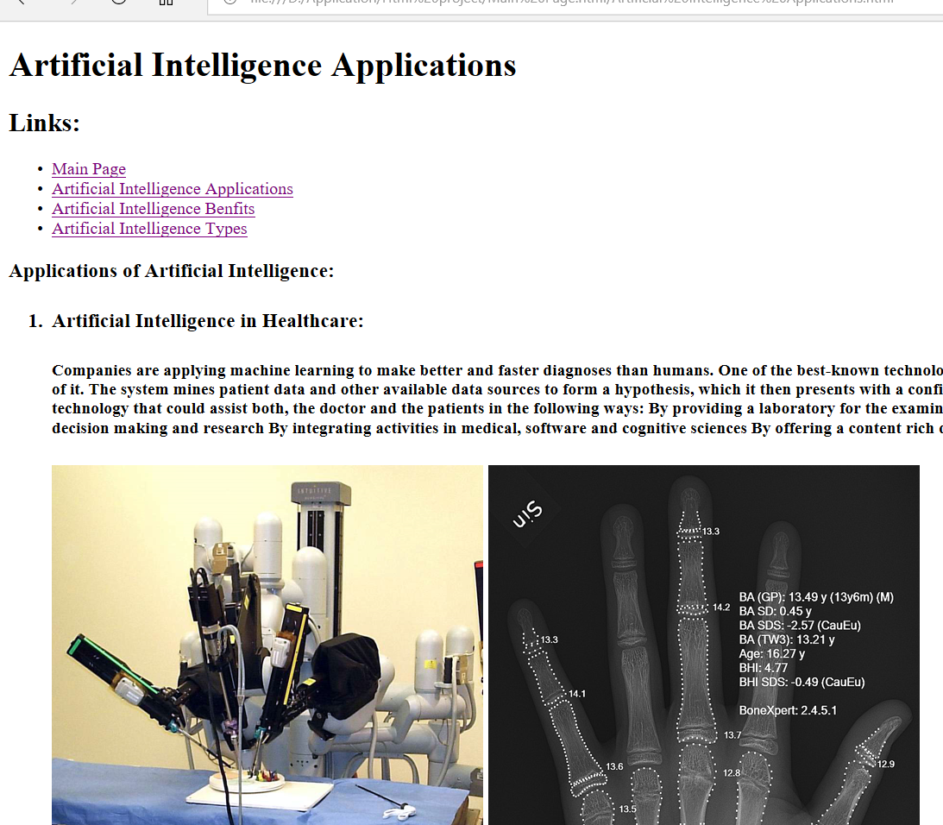

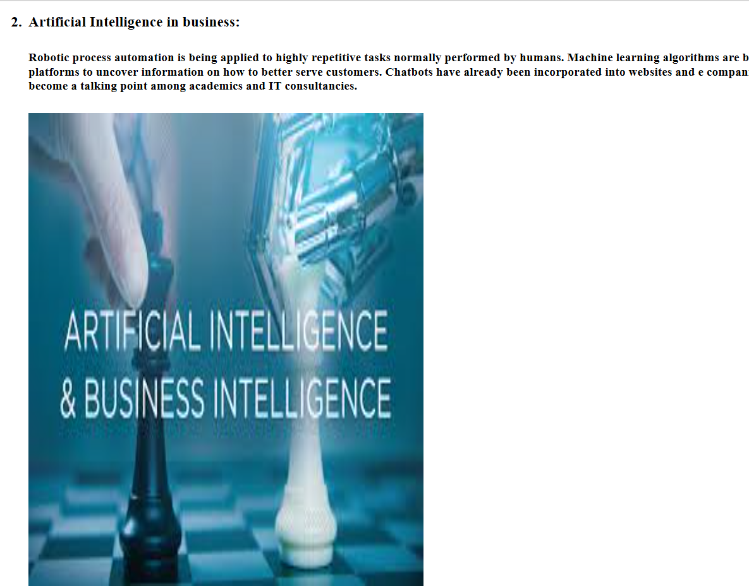

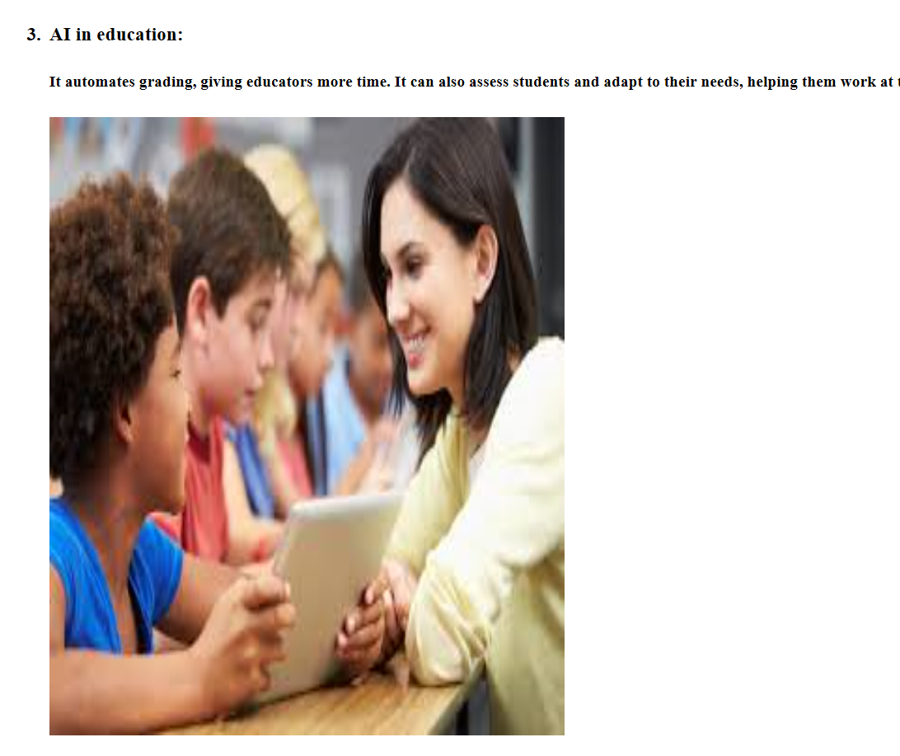

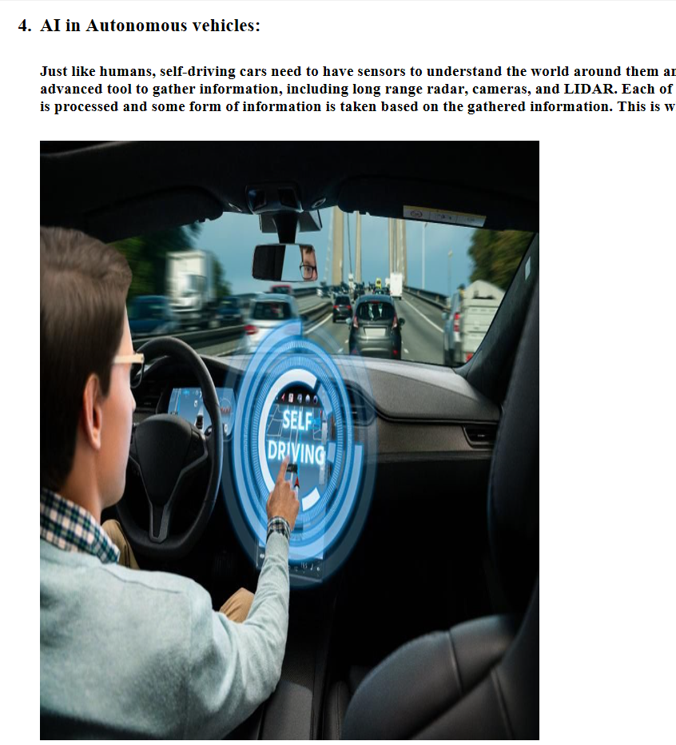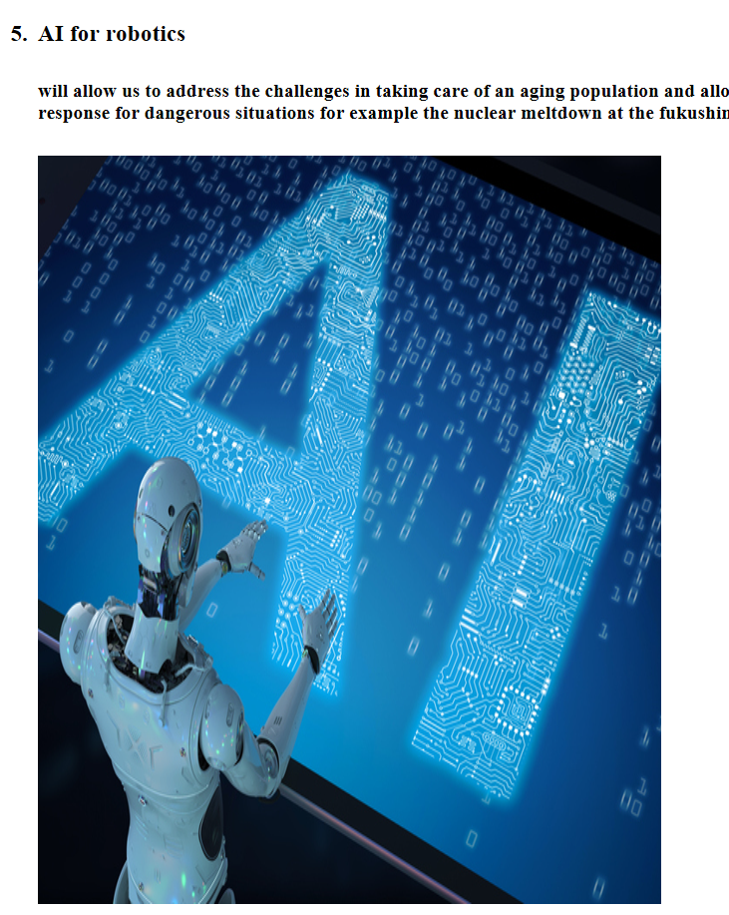

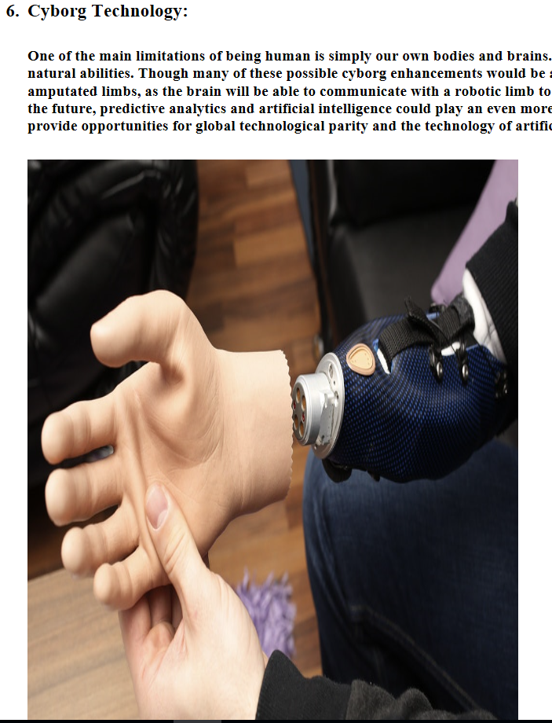

**Artificial Intelligence Benfits:**

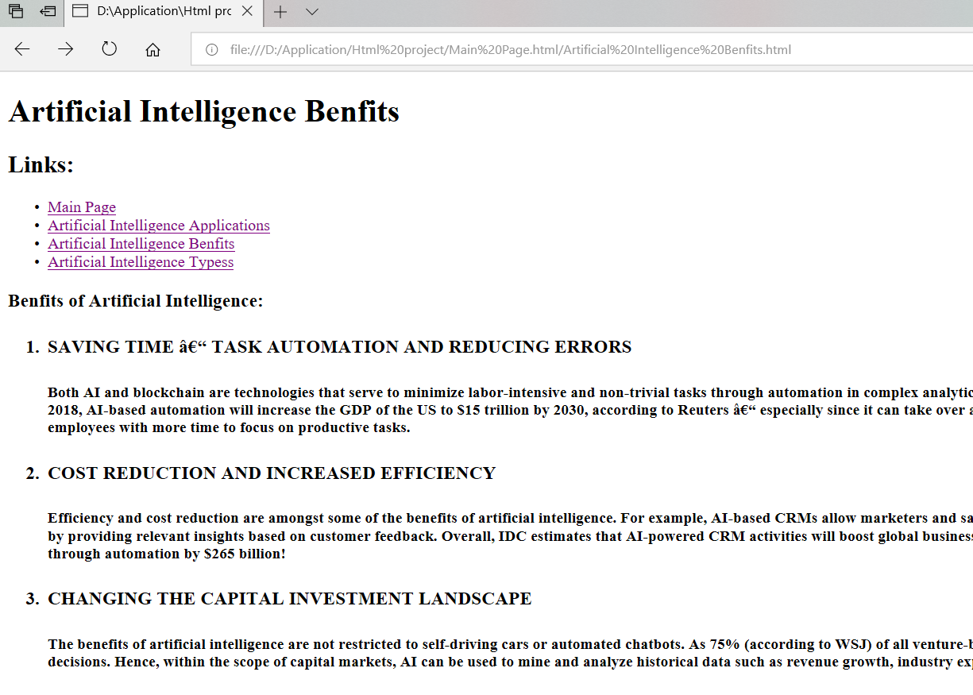

**Artificial Intelligence Types:**

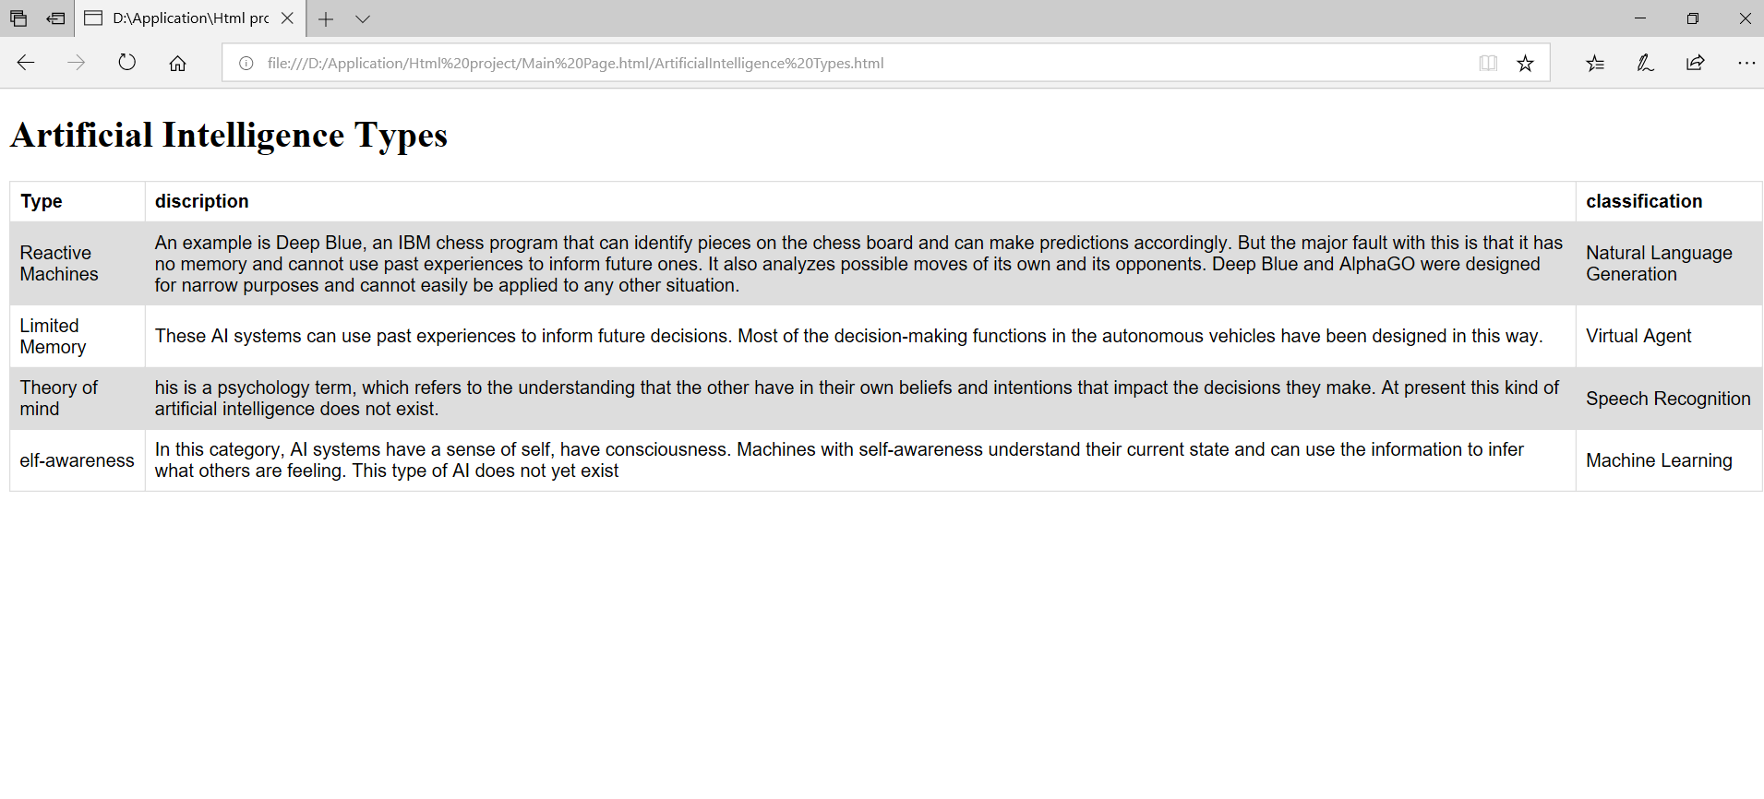

* **Source Code:**

**Main Page:**

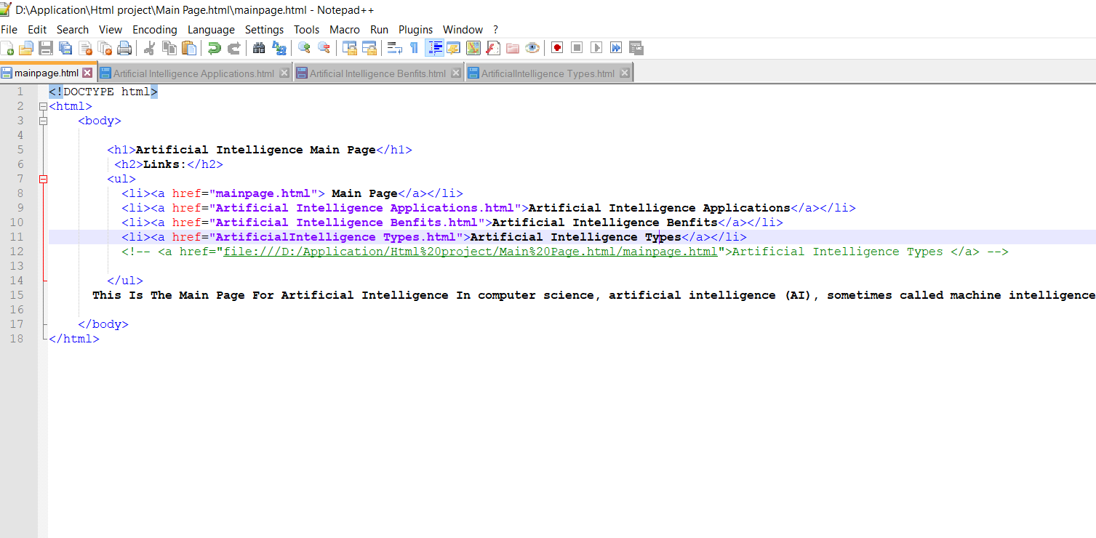

**Artificial Intelligence Applications:**

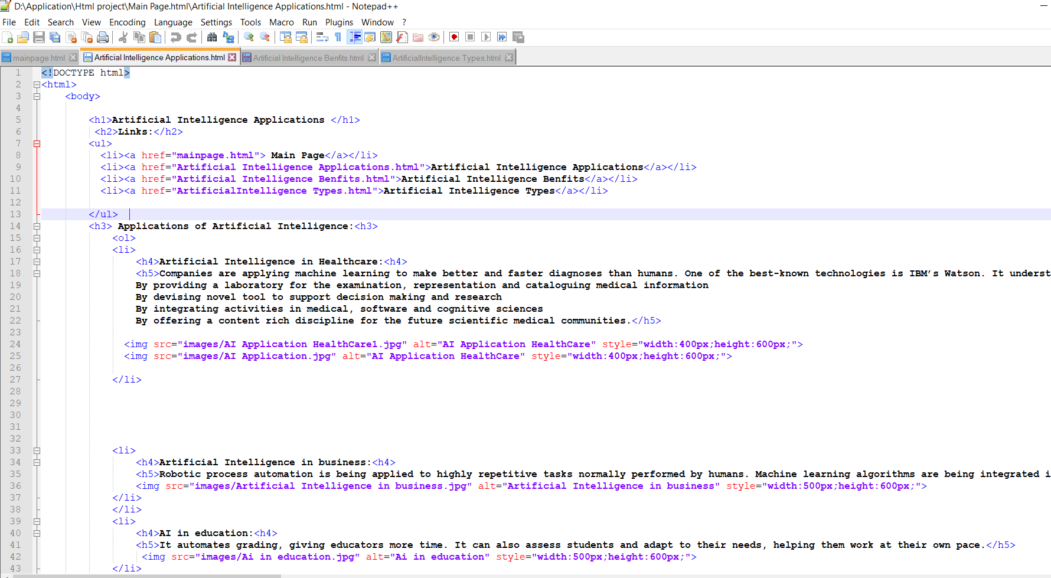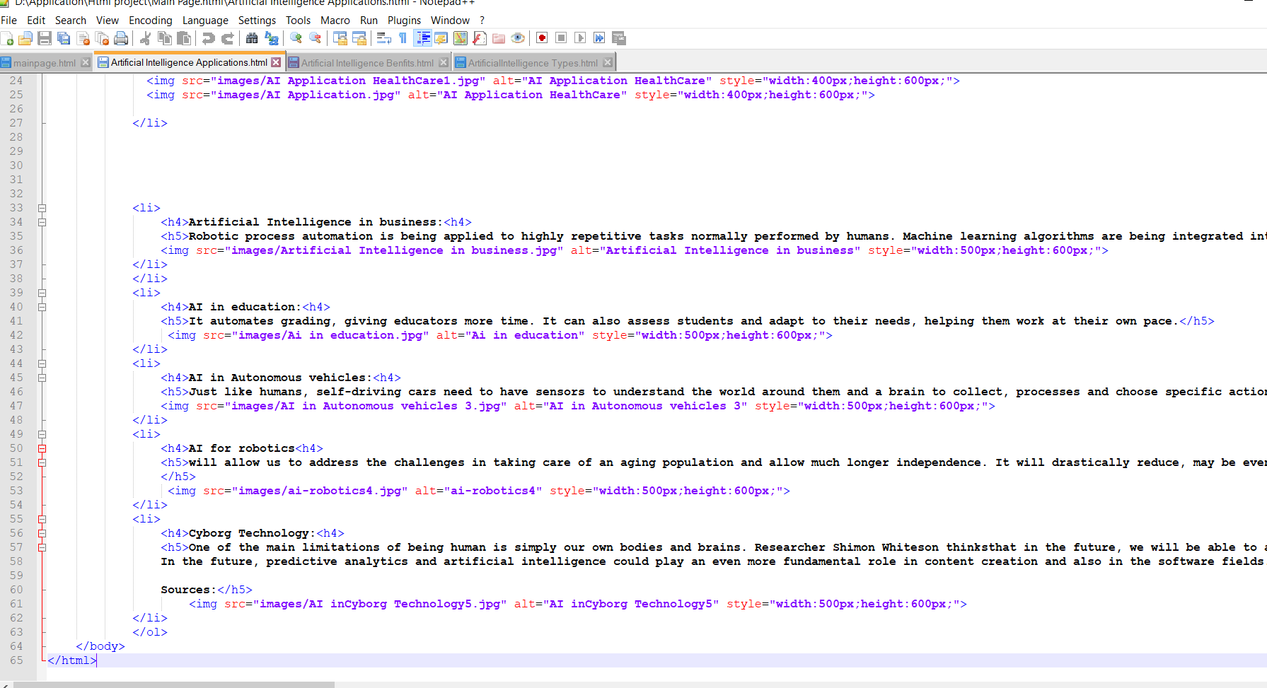

**Artificial Intelligence Benfits:**

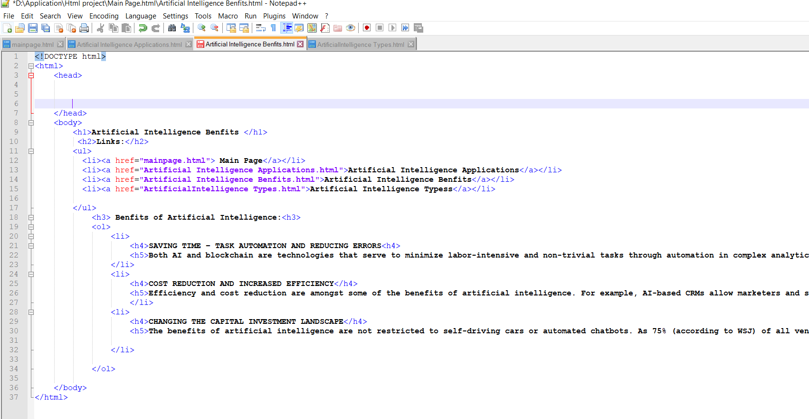

**Artificial Intelligence Types:**

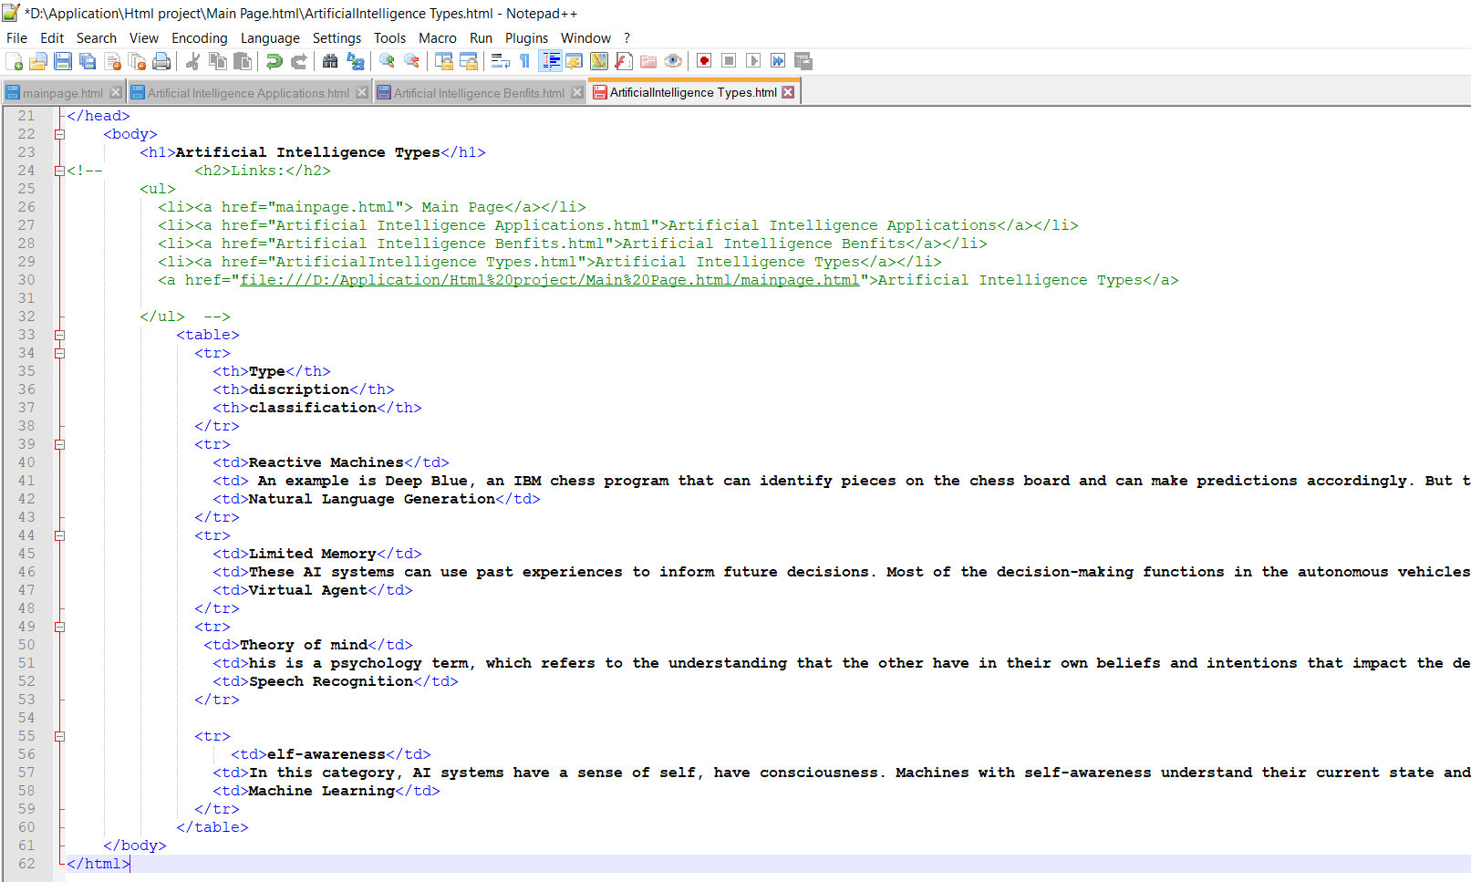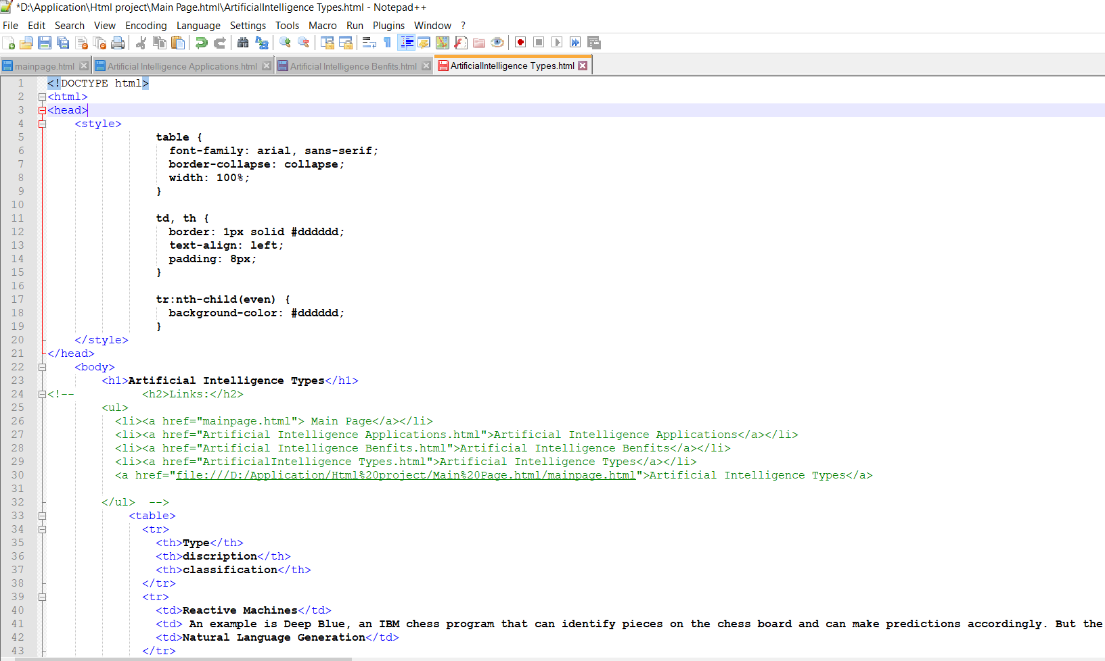

**References:**

* Aamodt, A. and Plaza, E. (1994). Case-based reasoning: foundational issues, methodological variations, and system approaches. AI Communications, 7(1): 39-59.
* Abelson, H. and DiSessa, A. (1981). Turtle Geometry: The Computer as a Medium for Exploring Mathematics. MIT Press, Cambridge, MA.
* Abramson, H. and Rogers, M.H. (Eds.) (1989). Meta-Programming in Logic Programming. MIT Press, Cambridge, MA.
* Agre, P.E. (1995). Computational research on interaction and agency. Artificial Intelligence, 72: 1-52.
* Aha, D.W., Marling, C., and Watson, I. (Eds.) (2005). The Knowledge Engineering Review, special edition on case-based reasoning, volume 20 (3). Cambridge University Press.
* Albus, J.S. (1981). Brains, Behavior and Robotics. BYTE Publications, Peterborough, NH.